Azure Functions: create, develop and deploy
  - Portal-first beginner hands-on lab
LBS | Attendee edition v2 | 26 October 2026

Before you start
Environment: use the instructor-approved sandbox, group, region, tiers and spending limit. Create only your own disposable resources. The walkthrough uses fictional data. No cloud resource is created by reading this document.
Materials: copy Labs\AppServiceSqlSample locally when the lab needs the .NET sample. Complete its setup from 02_Windows_And_Local_SQL_Setup.docx. Do not repeat resource creation if you already completed the same lab in the main guide.
Admin assistance: Contributor does not automatically grant IAM role assignment, SQL SELECT, Blob data access or Service Bus data access. Have the authorised administrator perform only the privileged step. Never bypass policy.
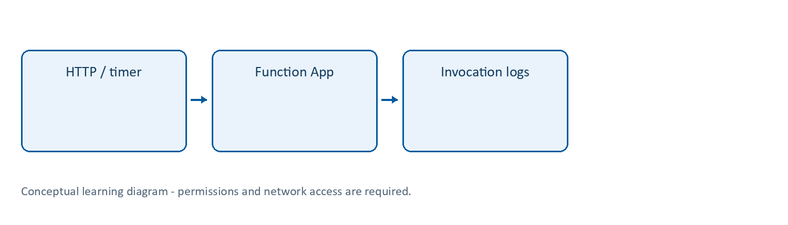
Learning flow

Azure Functions | Execute code when an event arrives
What: an event-driven application model. A Function App hosts one or more functions; a trigger determines what starts a function (HTTP, queue, timer, etc.). Bindings provide supported input/output integrations.
Why/when: useful for background work, scheduled jobs and event processing. A queue-triggered worker lets the caller stop waiting while work continues. It does not guarantee exactly-once execution.
How: create a compatible host/runtime/storage configuration; create a .NET isolated project in VS Code; test with Core Tools; configure connections and identities; deploy and verify invocations. Follow Lab 10.
Example: a queue message triggers validation of a fictional uploaded document.
Tips and traps: Function App is not the same thing as one function. Triggers need permissions and reachable dependencies. Use isolated .NET, not the retiring in-process model. Select a plan compatible with .NET 10; legacy Linux Consumption does not support it. Keep local.settings.json out of Git. Design idempotent handlers and bounded retries; prefer an explicit workflow/orchestration design for long-running multi-step processes.
Reference: https://learn.microsoft.com/azure/azure-functions/functions-overview

Lab 10 | Create and run a .NET Azure Function (extension)
Time: 35-45 minutes. Needs: current Functions extension/Core Tools v4, .NET 10 SDK, sandbox access and approved plan. Cost: execution, storage, monitoring and plan choices.

10A. Portal resource creation
- Create a Function App in the training group with unique name func-lbs-<suffix>.
- Select the instructor-approved Flex Consumption plan where available, Linux, and .NET 10 isolated worker. The legacy Linux Consumption plan does not support .NET 10.
- Use the approved region and create/select dedicated general-purpose storage for the host. Keep the portal-generated host/deployment storage configuration; it is separate from your Service Bus connection.
- Enable Application Insights using the course workspace if the wizard supports it. Otherwise connect monitoring after creation.
- Review pricing, identity and network defaults with the instructor. If the region/plan cannot offer the chosen runtime, do not select a preview or costly alternative silently; use an approved prepared Function App.
- Enable its system-assigned managed identity after creation.

10B. Create code in VS Code
- Create a separate folder LbsFunctions outside AppServiceSqlSample. Open it in VS Code.
- Run Azure Functions: Create New Project from the Command Palette. Select C#, .NET 10 isolated, and an HTTP trigger template. Name it HealthFunction.
- Choose Function authorisation for the deployed endpoint. Retain the generated project and worker package versions; they must support .NET 10. Do not select the older in-process model.
- Install/run Azurite if the generated local.settings.json uses AzureWebJobsStorage=UseDevelopmentStorage=true. You can use the VS Code Azurite extension and Azurite: Start. Keep the emulator running during local tests.
- Run dotnet build in this new folder. Start with F5 or func start (one host only). The Functions host normally uses port 7071, independently of the sample API’s 5080.
- Copy the exact function URL printed by the host and call it. Local Core Tools normally does not enforce function-key authorisation; do not mistake that for deployed anonymous access.

10C. Deploy and verify
- Stop the local host before switching settings. In the Azure Functions extension choose Deploy to Function App and select only your existing training Function App.
- Do not upload local.settings.json; it may contain developer secrets and emulator settings. Azure app configuration belongs in Function App environment variables.
- In the portal verify the HTTP function appears, then use Get function URL for its deployed URL/key. Test privately without pasting the key into chat, code or screenshots.
- Confirm a successful invocation in Application Insights. A function key is a shared secret, not Entra user authentication.
Checkpoint: the generated HTTP function responds locally and in Azure. Record the function name and status, not its key.

Lab 23 | Timer Function and queue-versus-topic practice
What/why: discover a second trigger and choose a messaging pattern based on business requirements, not service names.
Needs: working Functions project and Service Bus queue from Labs 10-11. Use a short approved test window.
- In VS Code’s existing LbsFunctions project, run Azure Functions: Create Function, choose a Timer trigger and name it LabHeartbeat.
- Set the schedule to 0 */5 * * * * (six-field Functions NCRONTAB: every five minutes). Retain RunOnStartup=false where configured; do not force production jobs to rerun on every restart.
- Review the generated log statement. It must log only a harmless timestamp/status, not credentials.
- Build and run locally with Azurite/required host storage as configured. Observe a scheduled invocation and confirm there is no HTTP URL required to fire this trigger.
- Stop the local host, deploy once and inspect the cloud invocation. Do not leave a second local copy running while testing other triggers.
- Record schedule/time-zone assumptions; default timer schedules use UTC unless supported configuration changes that behaviour. Do not assume your laptop’s local time defines cloud execution.
- Remove/disable the timer after practice using the supported function disable setting AzureWebJobs.LabHeartbeat.Disabled=true in the cloud app (matching the actual function name), or remove its source and redeploy. Confirm it no longer runs during the expected window.
- For Service Bus, peek the applications queue and explain competing consumers: two queue receivers do not each automatically receive their own copy of a job.
- If your existing namespace is Standard or higher, open Topics > Add topic, create application-events-practice, then create two subscriptions audit-practice and notification-practice. Inspect their default rules. Do not send real business events.
- If the namespace is Basic, record topics as unsupported and review the instructor’s prepared Standard example. Do not upgrade or create a paid second namespace without approval.
- Explain why independently interested audit and notification consumers fit subscriptions, whereas one document-processing job fits a queue. Inspecting topic/subscription resources is not proof that fan-out delivery has been tested.
- Delete only your empty practice subscriptions/topic after verifying their names. Retain the original queue for the connected exercise.
Expected: timer invocation observed and stopped; queue/topic choice justified; topic resources created only on an approved supported tier.
Log/cost notes: scheduled jobs can generate continuous executions and logs even when nobody browses the app. Timer retries/idempotency require deliberate design; a timer is not a complete workflow engine.
Security: trigger creation does not grant new Service Bus or storage permissions. Do not introduce a shared root connection key.
References: https://learn.microsoft.com/azure/azure-functions/functions-bindings-timer and https://learn.microsoft.com/azure/service-bus-messaging/service-bus-queues-topics-subscriptions

Completion record and cleanup
Record | Your observation
Subscription/group/region and actual resource names
Expected result and actual result
Log/table/metric, time range and evidence
Identity, role/scope and network restrictions
Idle/usage/logging cost driver
Cleanup or retention owner/deadline
Only mark a lab passed after its functional checkpoint. A deployment success or empty error table alone is not proof. Mark blocked permissions honestly.
Clean up only your own disposable objects; removing a diagnostic setting does not erase retained logs, and stopping an app does not stop every cost. Follow Lab 13 in the main guide. Keep secrets/customer information out of evidence.
Verification scope: these instructions and Word file structure were reviewed. Automated Word pagination could not be completed; preview before printing. Azure execution, prices, policy, permissions, plan/runtime availability and portal labels require instructor rehearsal in the actual training subscription.

